

Practices for Secure Software Report

Table of Contents
Document Revision History 3
Client 3
Instructions 3
Developer 4
1. Algorithm Cipher 4
2. Certificate Generation 4
3. Deploy Cipher 4
4. Secure Communications 4
5. Secondary Testing 4
6. Functional Testing 4
7. Summary 4
8. Industry Standard Best Practices 4

Document Revision History

Version | Date | Author | Comments
1.0 | 4/15/2026 | Blake Buhr

Client



Instructions

Submit this completed practices for secure software report. Replace the bracketed text with the relevant information. You must document your process for writing secure communications and refactoring code that complies with software security testing protocols.

- Respond to the steps outlined below and include your findings.
- Respond using your own words. You may also choose to include images or supporting materials. If you include them, make certain to insert them in all the relevant locations in the document.
- Refer to the Project Two Guidelines and Rubric for more detailed instructions about each section of the template.

Developer
Blake Buhr

Algorithm Cipher

The encryption approach selected for this project includes the use of the SHA-256 cryptographic hash algorithm in combination with HTTPS (TLS) for secure communications. SHA-256 is a member of the SHA-2 group of hashing algorithms and makes a 256-bit fixed-length output. Hash functions like SHA-256 operate by transforming input data into a fixed-length digest. The 256-bit length provides strong resistance against brute-force and collision attacks. The nature of SHA-256 ensures that the same input always produces the same output as well, allowing for reliable checksum verification. While SHA-256 itself does not use encryption keys, it is often used alongside secure communication protocols that do. HTTPS relies on a combination of symmetric and asymmetric encryption. Asymmetric encryption is used during the initial handshake to securely exchange keys, while symmetric encryption is used for efficient data transmission. Random number generation plays a critical role in this process by ensuring secure key creation and preventing predictability.

Historically, cryptographic algorithms have evolved to address increasing computational power and emerging attack methods. Earlier algorithms like DES and MD5 are now deprecated due to vulnerabilities. Modern standards like SHA-256 and TLS represent the current state of secure cryptographic practices.

Certificate Generation
Insert a screenshot below of the CER file.

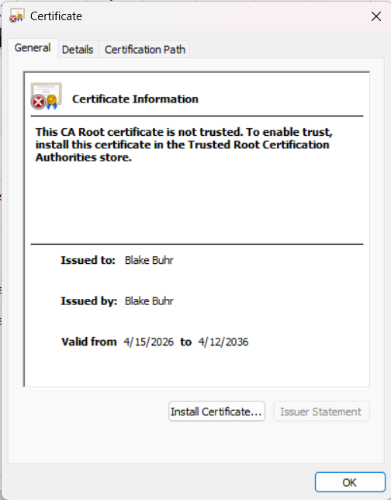

Deploy Cipher
Insert a screenshot below of the checksum verification.

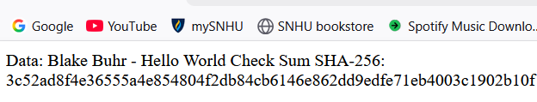

Secure Communications
Insert a screenshot below of the web browser that shows a secure webpage.

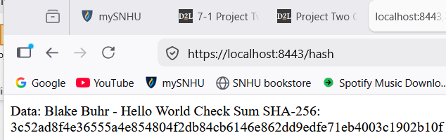

Secondary Testing
Insert screenshots below of the refactored code executed without errors and the dependency-check report.

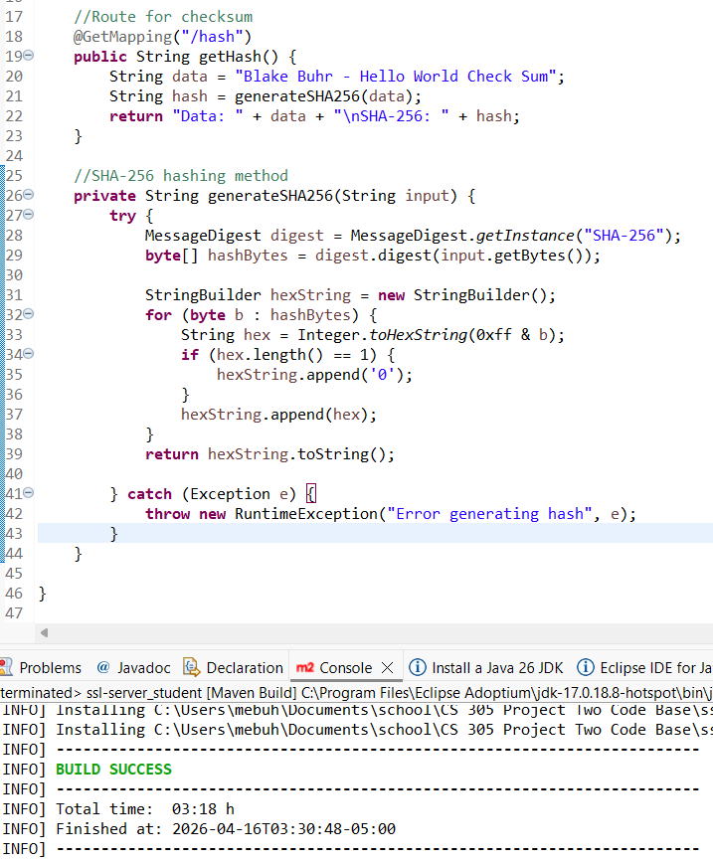
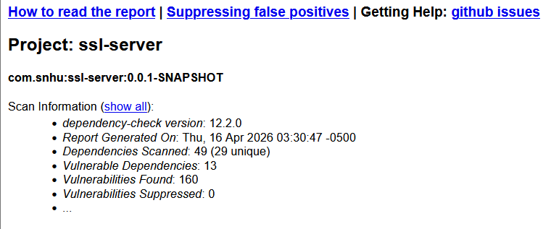

Functional Testing
Insert a screenshot below of the refactored code executed without errors.

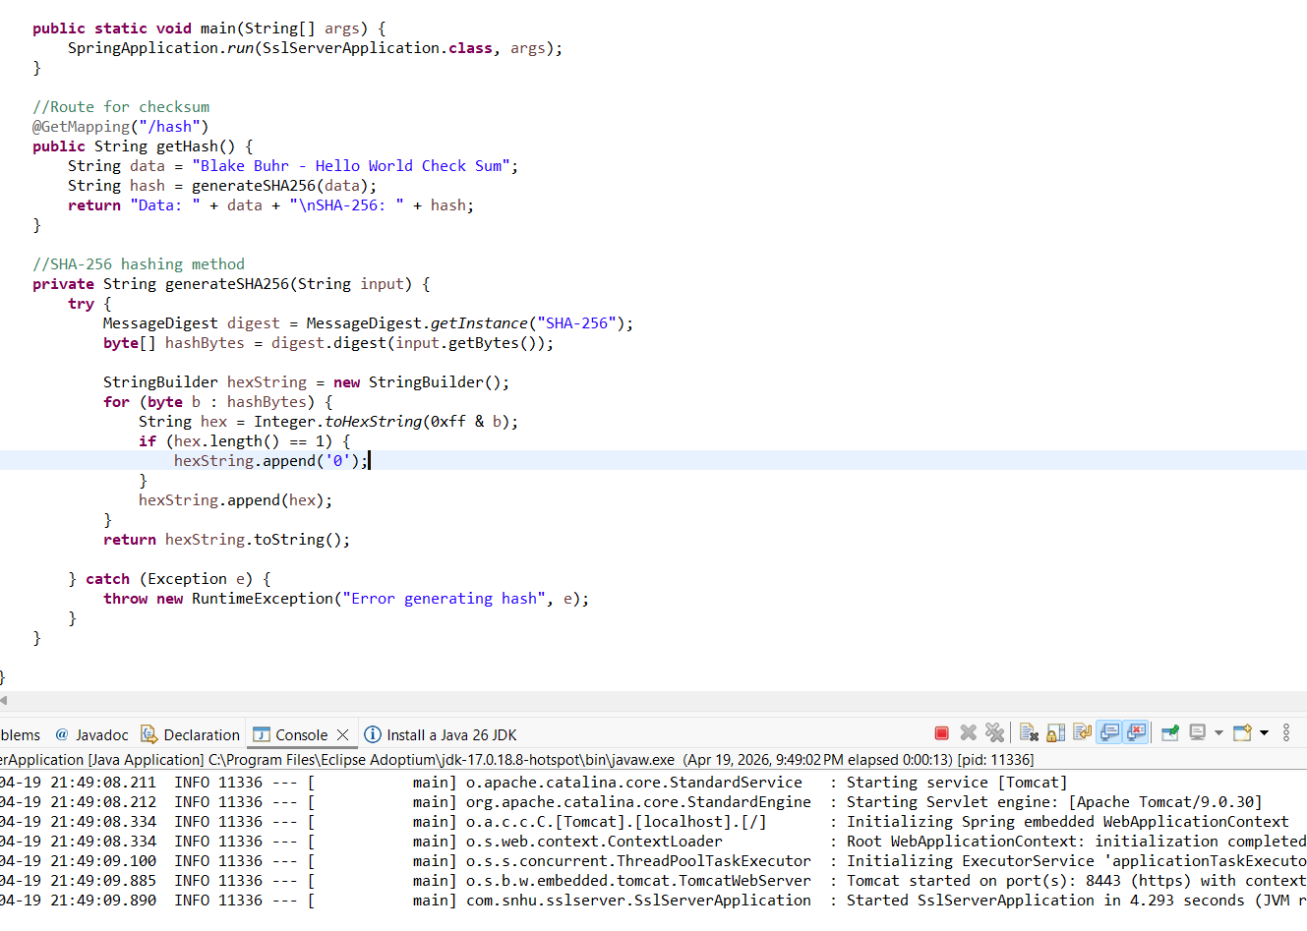

Summary

The application was refactored to improve overall security by implementing both data integrity and secure communication mechanisms. A SHA-256 cryptographic hashing algorithm was added to generate checksums for verifying data integrity, ensuring that transmitted data remains unchanged and tamper-resistant. Additionally, HTTPS was enabled by configuring SSL/TLS with a self-signed certificate, providing encrypted communication between the client and server.

Industry Standard Best Practices

Industry standard best practices for secure coding were applied throughout the process to mitigate known security vulnerabilities and strengthen the apps security. The implementation of the SHA-256 hashing algorithm follows modern cryptographic standards, providing a strong and collision-resistant method for verifying data integrity. Also, HTTPS was configured using SSL/TLS to encrypt data in transit, protecting sensitive information from interception or unauthorized access. Secure configuration practices were followed by utilizing a PKCS12 keystore format and properly managing certificate generation through the Java Keytool utility. The use of the OWASP Dependency-Check tool aligns with industry practices for identifying and assessing vulnerabilities in third-party dependencies, ensuring that security risks are understood and monitored.

